Project Title Wine Quality Classification
Algorithms Decision Tree | KNN
Objectives:
Classify wines as good or bad quality based on physicochemical properties like acidity, sugar, pH, and alcohol content. Build and compare a Decision Tree classifier and a KNN classifier.

Tasks to Complete: Complete
1 Load the Wine Quality dataset. Understand all feature columns and quality score distribution.
2 Binarize the target: quality >= 7 as Good (1), else Bad (0).
3 Perform EDA: visualize feature distributions and class balance.
4 Scale features using StandardScaler. Split data 80/20 train/test.
5 Train a Decision Tree classifier. Visualize the tree (max_depth=4).
6 Train a KNN classifier (try k = 3, 5, 7). Report best accuracy.
7 Plot confusion matrix and classification report for both models.
8 Identify which chemical features most influence wine quality using the Decision Tree.
9 Summarize findings: which model gave better results and what quality factors matter most.

Report:
- Load the Wine Quality dataset. Understand all feature columns and quality score distribution.
- Binarize the target: quality >= 7 as Good (1), else Bad (0).
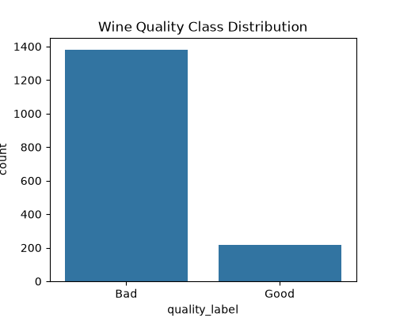

- Perform EDA: visualize feature distributions and class balance.

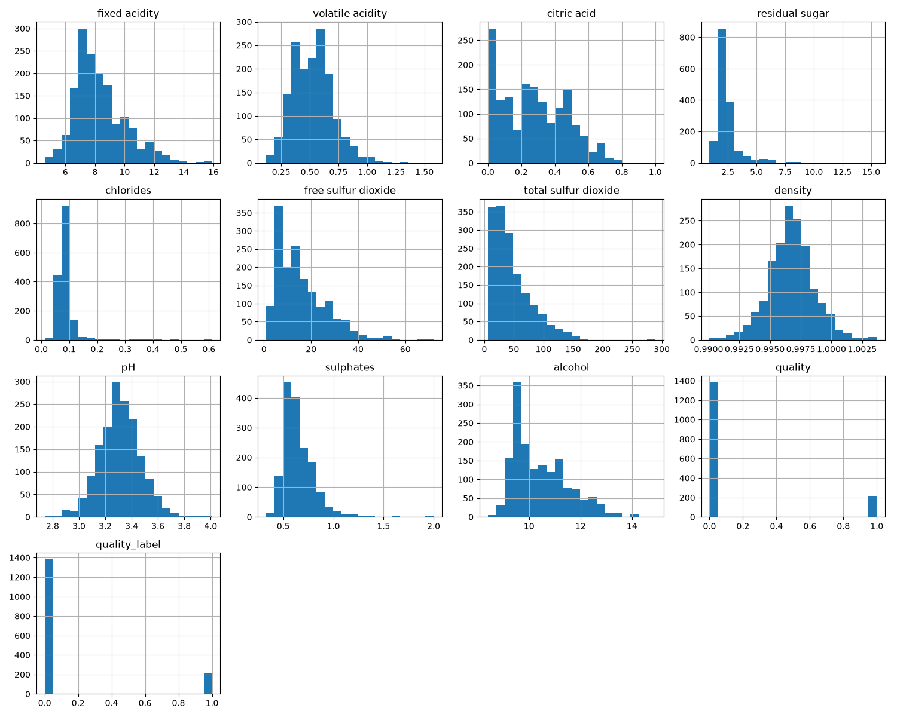
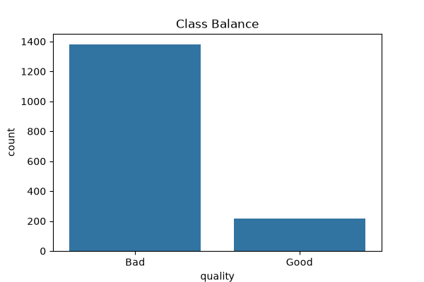

- Scale features using StandardScaler. Split data 80/20 train/test.
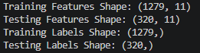
- Train a Decision Tree classifier. Visualize the tree (max_depth=4).
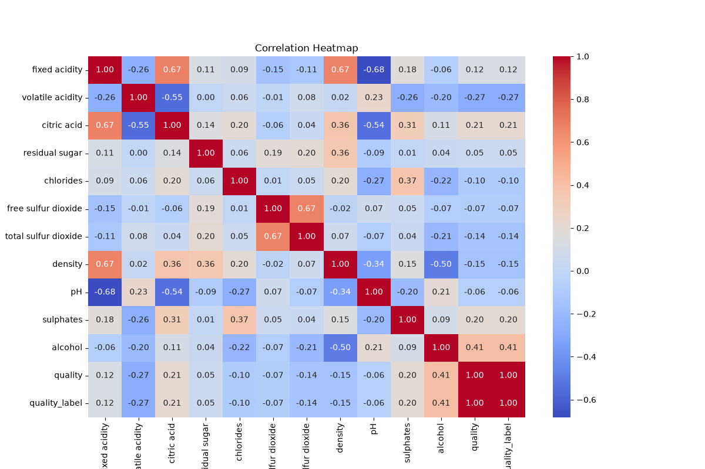
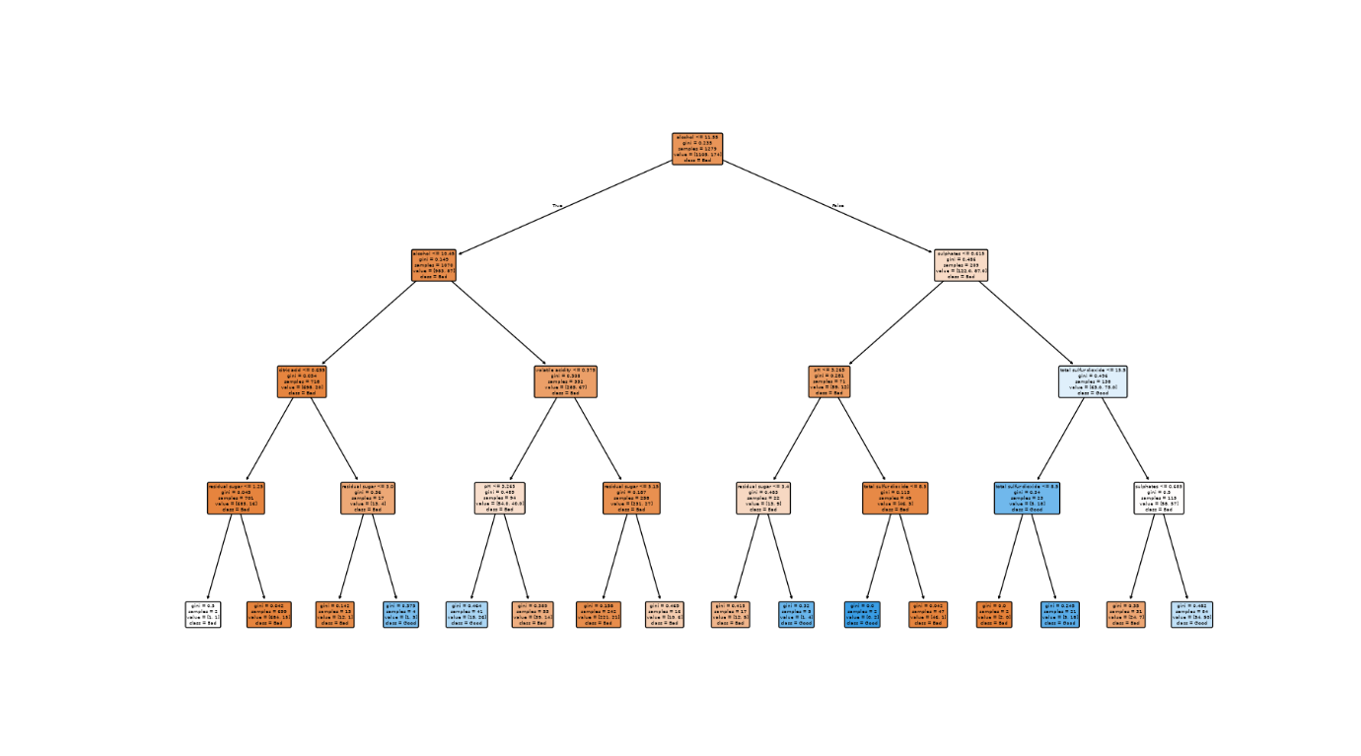

Decision Tree Accuracy: 0.934375
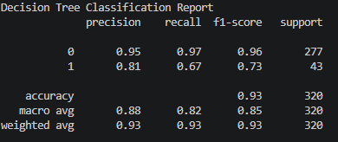

- Train a KNN classifier (try k = 3, 5, 7). Report best accuracy.
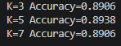
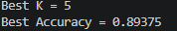
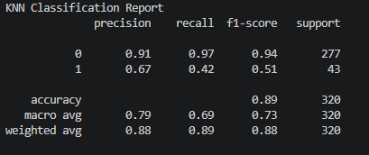

- Plot confusion matrix and classification report for both models.
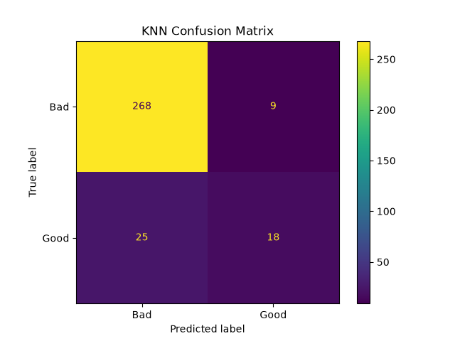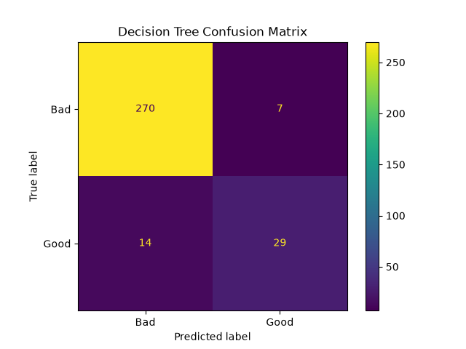

- Identify which chemical features most influence wine quality using the Decision Tree.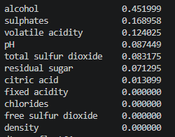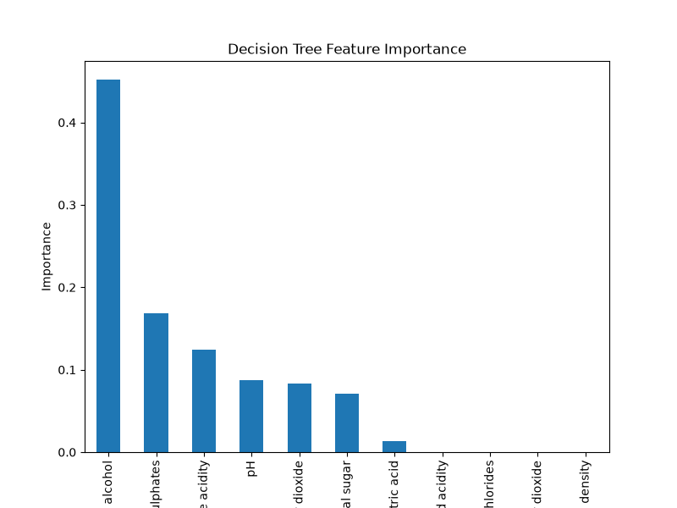

- Summarize findings: which model gave better results and what quality factors matter most.

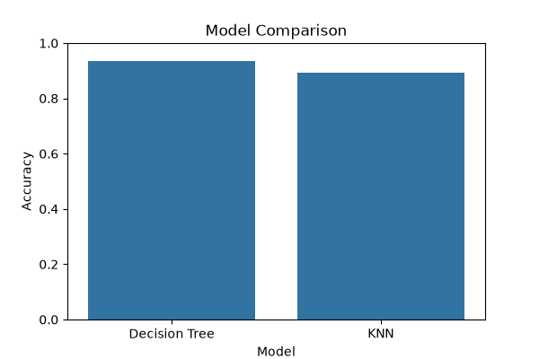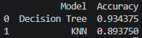

Decision Tree gave better results than KNN with an accuracy of 0.934375 over KNN’s accuracy of 0.893750. The Feature of Alcohol mattered the most, followed by Sulphates, Acidity and pH.

